Social innovation in the public sector
Participatory leadership in the European Commission

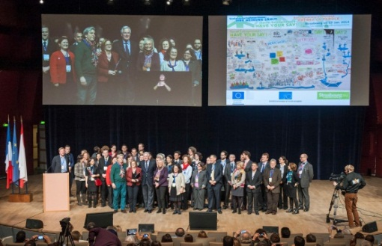
European Commissioner for the Internal Market and Services Michel Barnier summed up the Social Business Initiative event in Strasbourg on 17 January 2014 as follows: “This event proved that it is possible to truly co-create public policy, to bring different parties and different views together in an interactive way and create something that has real buy-in from all sides. I would like to see this way of working used right across the Commission.”
While the external context has called for a European Union that is more responsive and innovative in the face of social and economic challenges, staff within the European Commission have sought new – and more socially innovative – ways of working to build stronger internal resilience, cross-DG collaboration, and applied learning about systems change. Based on the premise of inviting participation, as is encouraged in Commission-supported external activities across the Union, this body of practice (the Art of Participatory Leadership) is a social innovation in itself – bringing new capacities, skills, approaches to the social structures and process that underpin day-to-day and longer-term strategic work.
The story so far
It started with a small group of individuals who shared a vision of potential - in this case, the potential (and true vocation) of the European Commission to convene the diversity of Europe around the future we want to create together. Some were Commission employees, others were working with the institution as consultants, yet others had nothing to do with the ‘Brussels bubble’ at all. Wherever we went, at all levels of the organisation, we kept hearing the same thing: “we need to find better ways of working together!”
We had in common that we were all practitioners of different methodologies allowing large numbers of people to talk together in structured and purposeful ways. And so we began to experiment inside the Commission’s daily routines. We met, trained and learned together, shared our different practices and applied them wherever and whenever the opportunity arose. We invited our colleagues, our teams, units, bosses, mentors, to experience the power of participation to enable more purposeful and impactful work. At times, it required courage as defined by C. Otto Scharmer (senior lecturer, MIT, 2007): "Courage comes from the willingness to go forth into an unknown territory that begins to manifest only after you dare to step into that void. That is the essence of leadership."
From very early on, the Commission’s central learning and development unit supported us in piloting a series of awareness-raising events and training seminars as a test run to confirm that this approach could work effectively in the Commission's context. Those events where open to all staff, following C. Bason recommendations in Leading Public sector innovation on employee-driven innovation (pp118-119): "to build innovation capacity, organizations must leverage the collective insight, tacit knowledge and inherent creativity in all (!) employees, not just certain managers, project teams, R&D staff or dedicated innovators."
Over time, the number of meetings, team-building events, strategic brainstorming sessions, change processes, stakeholder engagement programmes and networks and communities of practice run using this participatory operating system has mushroomed throughout the organisation. The scope, scale and ambition of the projects are constantly expanding and there is greater willingness to invest in deeper and more thorough preparation, reflection and follow-up.
Projects are developed by mixed teams, comprising both external consultants with long experience of the methods and internal staff with intimate knowledge of the organisational context and culture. Teams also tend to include ‘apprentices’, either practitioners new to the context or colleagues new to the practices.
Impact
Although the effect of these developments is hard to quantify, we see impact on many levels:
- Working better together: Colleagues report that participatory practices change the way they communicate and plan their work; that it helps them listen better: to each other as colleagues, to citizens, to the needs in any given context; and that it helps them to share their knowledge. When properly applied, colleagues experience the power of co-creation, which is key to social innovation.
- Better results: Processes run with participatory approaches tend to produce better results – both tangible (content output – policy and strategy) and intangible (people often leave more energised, engaged and motivated). There is much more interaction between people attending meetings, which makes for a denser network of relationships outside meetings, contributing to a more robust ecosystem at all levels of scale. However, the organisation has not always been able to absorb the output from engagement processes. When this happens, there is a risk of leaving participants frustrated, even cynical, and unwilling to engage further in participatory events.
- Bridging the gap: citizens and stakeholders attending participatory events run by the Commission often report that their opinion of the European institutions is greatly improved by the experience. New approaches to inter-service and inter-institutional collaborations lead EU staff to experience more generative collaboration. Staff also often report that they feel more motivated, engaged and satisfaction to work in this way, which allows them to put their talents to better use in service of the whole organisation.
- Beyond the institutions: Consultants working in this context are strengthening their own capacity to host innovative work in their own countries. Governmental organisations across Europe (and beyond) are inspired by what they hear and experience of the work led by the Commission.
Making it sustainable
- Organisational development: The Commission’s Human Resources department has created a dedicated team of internal consultants serving the whole organisation. Other departments are now also creating similar functions to serve their local needs.
- Capacity building: 1200 managers and staff have participated in 3-day introductory training seminars (33 seminars held to date). Typically, these seminars are phenomenally productive, providing an opportunity for colleagues to prototype participatory projects for their own contexts.
- Community of practitioners: a close-knit, self-organising community of practitioners has emerged, distributed across the organisation, expanding into other EU institutions and agencies, as well as in the professional organisational development community throughout Europe.
The challenge of co-habiting paradigms
The participatory paradigm goes way beyond simply applying a set of conversational techniques. The world view and language that support participation often disturbs in a context where collaboration is habitually structured through lines of hierarchy and organisation charts. For participation to achieve its full potential we have to break habitual patterns. Inevitably, this sometimes creates confusion and resistance, as it challenges people to go beyond their usual ways of working. This interface between two such contrasting paradigms is a rich breeding ground for continual learning and innovation. When handled skilfully, this can deliver results beyond all expectation.
"Sometimes, when it comes to innovation, the best leadership practice is stretching or breaking the rules, interpreting a directive rather loosely to do something different." (C. Bason; Leading public sector innovation, Co-creating for a better society, 2010, p252).
It’s all about “collective” – and it’s contagious!
The power of this approach lies in its collective nature: collective leadership informed by collective intelligence – sometimes even wisdom. Participation is messy – especially in complex systems. It invites diversity as a key driver of innovation, and divergence, which often looks chaotic and feels uncomfortable. Paradoxically, the only way to move forward is together. The next challenge – that we are currently starting to grapple with - is taking participation to the next level of scale, including building the necessary capacities to support it, and to track its impact in a more consistent manner.

Annex: Examples of participatory projects convened by the European Commission
The few examples below show the diversity of applications of participatory leadership practice in the European Commission's context and the variety of methodologies of this approach.
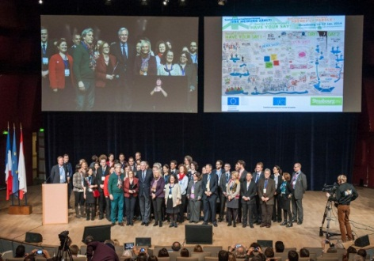 | On 16-17 January 2014, 1800 participants from 70 countries - social entrepreneurs, EU staff, researchers and social innovation financers - gathered in Strasbourg at the Social Business Innovation Event convened by the European Commission, the European Economic and Social Committee and the City of Strasbourg and its partners. The event was followed by 1800 citizens via webstreaming. The results were crystallised in the Strasbourg Declaration, a tool for change and for developing the eco-system of social innovation in Europe.
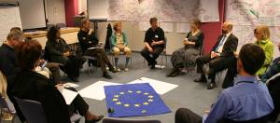  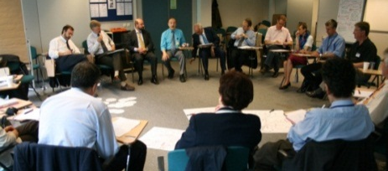 | At the start of all this, in 2006-7, a circle of pioneers gathered around their passion for the EU project. First as private individuals and then at the EC, when the central learning & development unit gave them some space and resources, they started experimenting participatory leadership practices with the aim of enabling the European Commission to promote Eu’s development and transformation at its full potential. They followed innovation management principles and phases as in ideation, concept development, experimenting, prototyping, testing, implementing, and scaling is where we are currently and that is one of our future challenges.
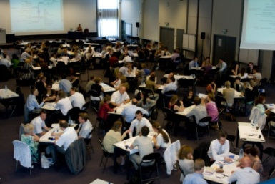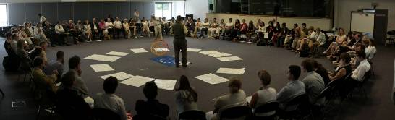 | In 2009, DG Human Resources and DG Communication jointly hosted an Internal Communication & Staff Engagement seminar 'Commission vision, values and purposes' with 160 participants from all across the Commission. 3 Directors General, 40 senior managers and representatives of 4 key networks (internal communication, external communication, strategic planning and programming, HR), engaged together around our shared purpose for Europe and identified 15 key development areas to further work on, which were followed up on by the people who raised them.
 | 2 consultations in 2010 and 2011 (each with 120 stakeholders) on the future Europe for Citizens Programme allowed the team in charge (in DG Communication) to collect the key elements of the next programme, build the ground inside their DG and with their Cabinet, and draft the required impact assessment and the Commission proposal for a regulation. The new Programme was launched on 28th January 2014.
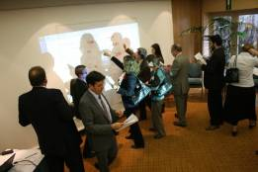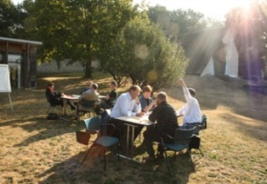 | Between 2008 and 2010, a series of 9 senior leadership seminars invited directors of the EC and the EU agencies to meet as peers and engage a reflection on the future of the EU, which later became the Europe 2020 strategy. Half the Commission’s directors participated. We also hosted two senior leadership retreats at Jean Monnet's house to help senior managers from REGIO and MARKT reconnect their work today with Monnet's initial inspiration to build modern Europe.
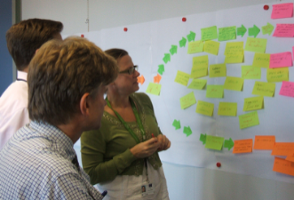 | The Strategic Planning and Programming community of practitioners has worked relentlessly since 2008 to improve the way strategic planning is practiced in the institution. They use participatory leadership practices as their operating system, and have succeeded in formulating solid recommendations for improvement of one of the institution’s core processes, most of which have been endorsed by the Secretary General.
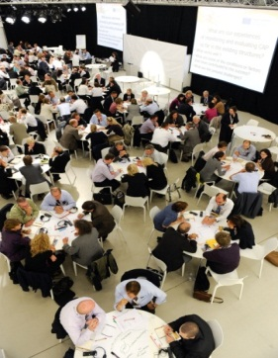 | In 2011, DG Agriculture consulted 230 key stakeholders from across Europe on Monitoring & Evaluation for the Common Agricultural Policy after 2013. Through collaborative work around 23 areas, the participants created a common ground to develop a future monitoring and evaluation system that could improve policy performance and demonstrate policy achievements.
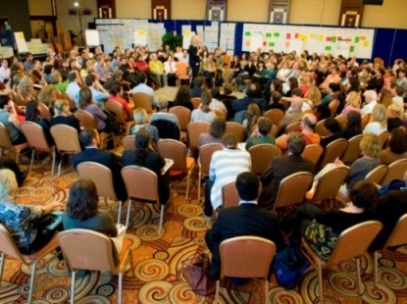 | The Europe Direct Information Centres annual general meeting of 2011 brought together 450 representatives of the centres, network correspondents in the EC Representation offices, EC services and other institutions to share what they had learnt from the current generation of programmes and provide input into the definition of the next one starting in 2013. Following this positive experience, the first two annual general meetings of this new generation of Europe Direct Centres have also been organised in a participatory way.
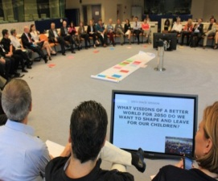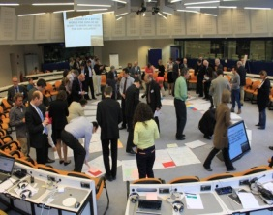 | To kick off the Digital Futures initiative launched by DG Communications Networks, Content and Technology in 2012, we gathered 60 foresight experts from Europe and beyond in a participatory workshop to co-create visions of the future of Europe as transformed by digital technology by 2050.
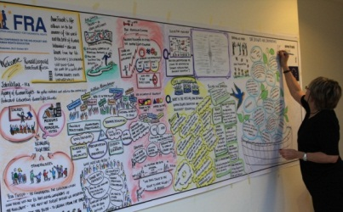 | In October 2011, the EU Fundamental Rights Agency, DG Communication's Europe for Citizens team and the Anne Frank House held a conference on the Holocaust and Human Rights Education in Amsterdam. The conference brought together memorial sites/museums and teachers, Holocaust education and Human Rights Education practitioners, and others. The participants explored the most appropriate ways to connect human rights and Holocaust education, and share practices and activities as a community of practitioners.
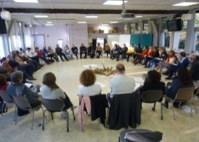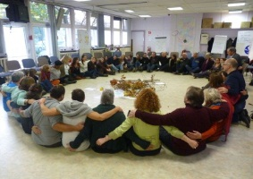 | Participatory Leadership training seminars and practitioners' gatherings have played a crucial role in building the capacities needed to support all the developments described here. Increasingly, such activities are organised in specific departments of the EC to support their development by building strategic competence.

Told from the perspective of the intrapreneurs – written by Matthieu Kleinschmager & Helen Titchen Beeth with input from the community of practitioners.
Such as Open Space Technology, World Café, Circle, collective mind-mapping, Action Learning…

